Temple Beth David and Temple Beth El Present

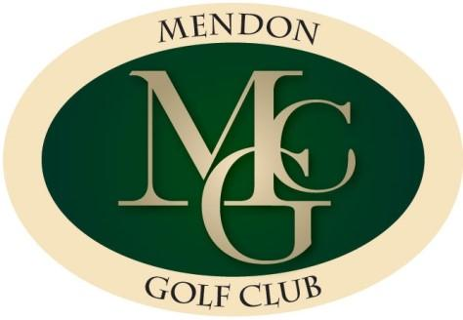
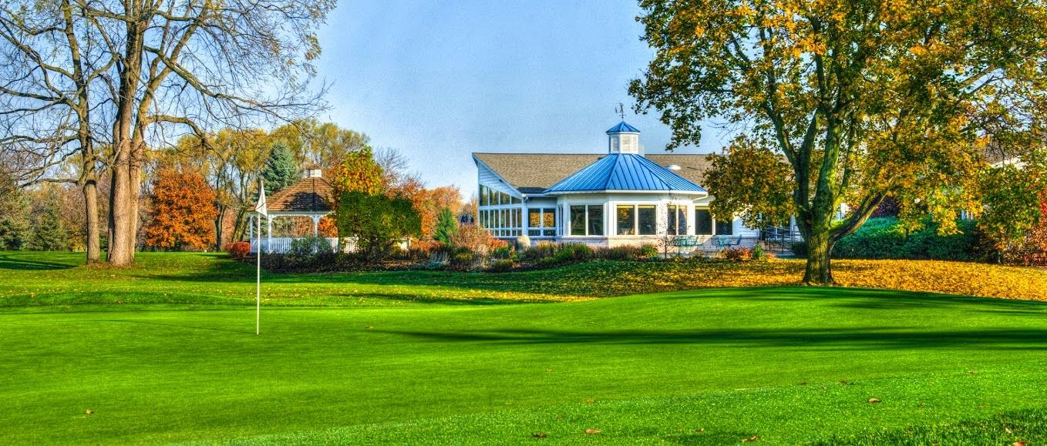
6th Annual Joint Golf Outing
@ Mendon Golf Club (Mendon, NY)
Monday, July 31st, 2023
in memory of Jay Cohen and to benefit TBD and TBE

Golf, Breakfast, Lunch and Hors d’oeuvres
$150.00 early bird before 7/1
$175.00 after 6/30

8:30am Registration, breakfast, team pictures
10:00am Shotgun tee start
4:00pm Hors d'oeuvres @ Mendon Golf Club

Register for golf/sponsorship online @ https://www.tberochester.org/

SPONSOR OPTIONS

Sponsor signs will be placed on the golf course and displayed at the hors d’oeuvres
Sponsor Name:
Wording for Sign:
(if no wording for the sign is written, we will use the Sponsor Name)
Sponsor Address:
Sponsor Phone:
Sponsor Email Address (needed for graphic):
Sponsor Web Address:

*** ALL SPONSORS GET MENTIONED IN OUR EVENT BOOKLET (which is handed out to all attendees)

( ) Platinum Hole Sponsor | Includes golf for four (4) people | $1500.00
( ) Gold Hole Sponsor | Includes golf for two (2) people | $ 800.00
( ) Silver Hole Sponsor | Includes golf for one (1) person | $ 500.00
( ) Bronze Hole Sponsor | Includes hors d’oeuvres for one (1) person | $ 250.00
( ) Breakfast Sponsor | Includes breakfast for one (1) person | $ 150.00
( ) Hors d’oeuvres Sponsor | Includes hors d’oeuvres for one (1) person | $ 150.00
( ) Golf, breakfast, lunch &  hors d’oeuvres | Includes golf, breakfast, lunch and hors d’oeuvres | $ 150.00  6/30 Price Increases to $175.00
( ) Hors d’oeuvres only |  | $ 50.00

REGISTRATION FORM FOR GOLF AND/OR SPONSORS

 |  |  |  | Lunch Choice
Name | Phone | Email | Amount Enclosed | Veggie Burger | Tuna | Veggie  Wrap
 |  |  | $
 |  |  | $
 |  |  | $
 |  |  | $
 |  | TOTAL | $

Affiliation: TBD TBE Both Unaffiliated

Please make checks payable to Temple Beth El with “Golf Outing” Temple Beth El
on the memo line and mail to: 139 Winton Road South
Rochester, NY 14610
Registration forms must be in by Friday, July 14th, 2023 Attn: Golf Outing
If you have any questions please call:
TBD: Scott Davis (585) 360-7011 or email sldavis1@gmail.com
TBE: Evan Spindelman (585) 415-1245 or email evans@lombardcecil.com

