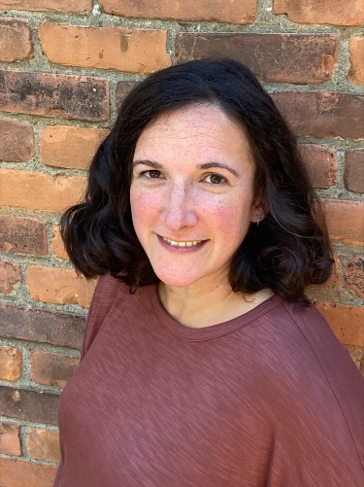

Jenny Mural, LCSW, IMH-E®

Jewish Family Services Counseling Center

Phone/Text: 585-250-1324

Email: jmural@jfsrochester.org

Jenny is one of the new therapists at the counseling center with JFS. She holds a Bachelor’s degree in Psychology from the University of Rochester (2002) and a Master’s Degree in Social Work from Virginia Commonwealth University (2006). She has over 15 years of experience working with children and families in the Rochester community impacted by trauma, grief and loss, family dynamics and issues around social and emotional development across settings, including home-based work. Jenny has specialized training in Perinatal Mental Health, Infant Mental Health and Parent Coaching. She is committed to offering support to all caregivers working with and on behalf of young children through the lens of supporting healthy, nurturing interpersonal relationships. In her professional and personal roles and relationships, Jenny holds a deep appreciation for creating space for reflection to foster understanding of oneself and others within the context of relationships. She is excited to partner with the parents and staff at Keshet Preschool to support the ongoing social, emotional development of the children. Jenny anticipates being on site at Keshet on Thursday mornings but please feel free to use the contact information above to reach out at any time.

