Tequila Barrel Fundraiser

In support of Temple Beth El’s

5786 High Holiday Campaign

Join in the “spirit” of our High Holidays.
Sponsor the Spirit!
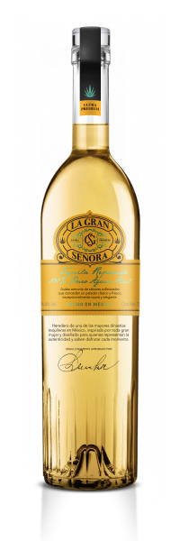
It’s another first! Temple Beth El is purchasing a “single barrel” of La Gran Senora Reposado Tequila from the premier brand Tequila Supremo, distilled in the iconic town of Arandas, Jalisco, Mexico.
Our Temple Beth El tequila connoisseurs conducted their own sensory evaluation, and they selected our barrel.
The distillery will be bottling our limited series barrel this summer, exclusively for Temple Beth El, with a Temple Beth El label added to the bottle. We will receive about two hundred 750ml bottles!

Will you help sponsor this fundraiser?
There is a limit of 50 sponsorships available.
The minimum sponsorship level is a donation of $500 (one sponsorship unit). As a thank-you, you will receive our thanks, plus three bottles of tequila. You are, of course, welcome to donate $1,000 or more, and receive a lot of thanks plus an additional three bottles per $500 donation.
Please consider donating to this community-building, unique and fun fundraiser. For questions or more information, contact Jack Finkelstein at jnfink49@gmail.com.
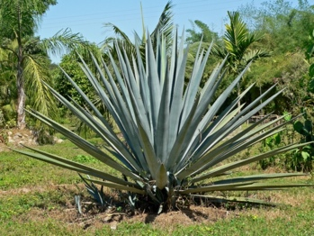
Blue Weber Agave succulent

